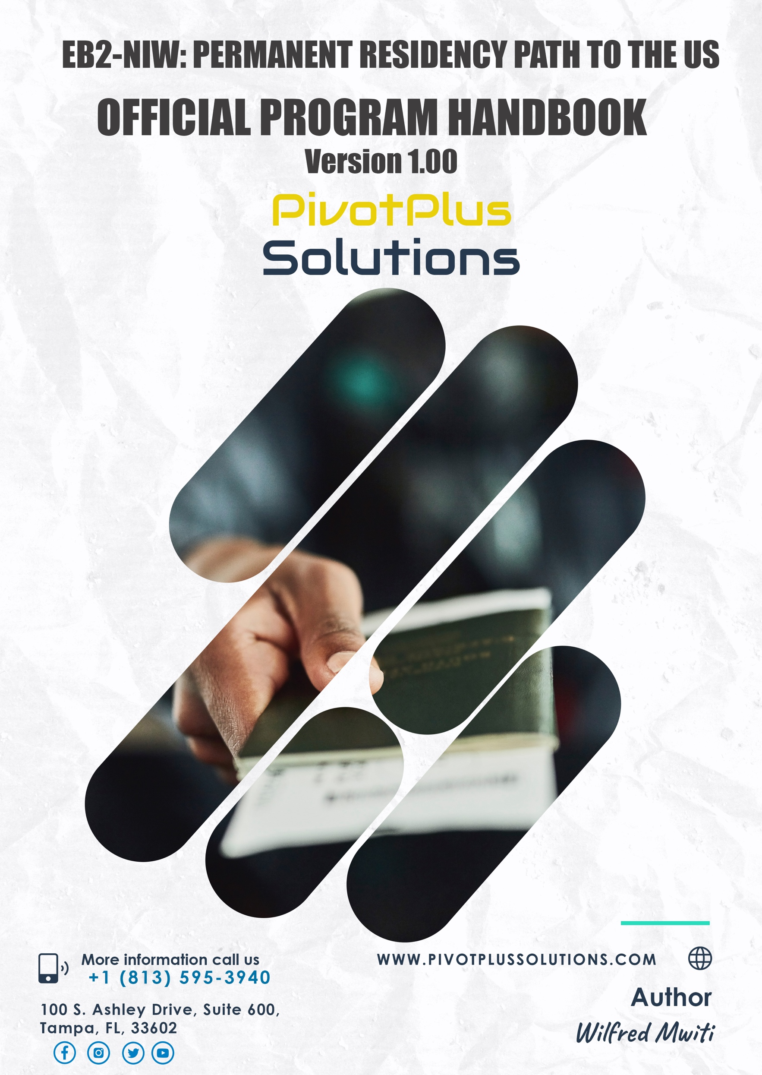

TABLE OF CONTENTS

INTRODUCTION 2
HOW EB2-NIW WORKS 2
WHAT YOU NEED TO PROVE 3
Advanced Degree Requirement 3
Exceptional Ability 3
National Interest Waiver (NIW) 4
CHANCES OF APPROVAL 4
DURATION AND EXPEDITE OPTIONS 5
FEES AND PAYMENT OPTIONS 6
Our Fees 6
Other Costs (Paid to USCIS): Filing Inside the US 6
Other Costs (Paid to USCIS): Filing Outside the US 7
SCHEDULE A CONSULTATION WITH US 8
RECOMMENDATION LETTERS AND PROOFS OF EVIDENCE 8
LIABILITY DISCLAIMER 9

INTRODUCTION

Every year, the US government usually allocates approximately 40,000 Employment-Based Second Preference (EB2) National Interest Waiver (NIW) visas to people drawn from different nationalities. The EB2 NIW visa category allows foreign nationals to secure permanent residence in the US without needing an employer sponsor. Anyone meeting the qualifications can apply regardless of whether they are in the US or not. Unfortunately, despite a substantial number of people qualifying, only a small segment knows about this type of visa or the process surrounding successfully applying. Additionally, complexities in navigating through different requirements make it difficult for many to try out EB2 NIW.
With proper guidance from credible professionals and experts, the EB2 NIW is undoubtedly one of the best pathways to securing a green card to live and work in the US and bring your spouse and children if they are under 21. Because the journey can be mostly daunting and require a great deal of time and effort, our personalized services lessen the burden off your back by providing you with optimum guidance to secure your green card.

HOW EB2-NIW WORKS

The U.S. government's waiver of the job offers and labor certification requirement for the EB-2 NIW visa is based on the premise that the applicant will either contribute specific expertise or perform a function of national interest. This could be because a governmental body has determined it so, the applicant is uniquely qualified, there are few professionals in that field in a certain region, the proposed work is distinctive, or the applicant intends to be self-employed in the U.S.
The EB-2 NIW visa is typically granted to professionals who can demonstrate that they will significantly benefit the United States. In addition to meeting the specified requirements, this could involve continuing to work in their field, joining professional organizations in the U.S., starting a business, conducting research, performing in their art, or competing and training others in their sport.
U.S. immigration aims to grant residency to professionals considered "above average." This determination is made based on 7 criteria set by law. If an applicant can demonstrate that they meet at least three of these criteria, they are deemed to possess "exceptional ability." Once this is established, the applicant must also show that they will not become a public charge or displace a similarly qualified worker in the U.S. labor market. The focus is on explaining how their experience or future plans will benefit the U.S. labor market.

WHAT YOU NEED TO PROVE

- Have an Advanced Degree
- Exceptional Ability
- Meet the 3 requirements for a national interest waiver, which are that:
  - The proposed endeavor has both substantial merit and national importance.
  - Well-positioned to advance the proposed endeavor, and
  - On balance, it would be beneficial to the United States to waive the job offer and labor certification requirements.

Advanced Degree Requirement

Many people mistakenly believe that only extremely exceptional individuals, like Oscar winners or top scientists, are eligible for this visa. However, if you have EITHER of these qualifications, you can apply:
- A bachelor's degree and a minimum of five years post-graduation experience
- A graduate or master's degree. For those with a postgraduate degree, the five-year experience requirement is waived.
- Individuals without formal education may still qualify if they have at least ten years of experience in their field and have received recognition for their work, such as an award or similar honor.
You must provide Documentation, such as an official academic transcript and degree certificate, showing that you have a U.S. advanced degree OR a foreign equivalent degree.

Exceptional Ability

The 7-criteria rule used by the United States Citizenship and Immigration Services (USCIS) to evaluate exceptional ability encompasses the following in which one must satisfy at least 3 of the listed requirements:
- Official academic record showing that you have a degree, diploma, certificate, or similar award from a college, university, school, or other institution of learning relating to your area of exceptional ability
- Letters documenting at least 10 years of full-time experience in your occupation
- A license to practice your profession or certification for your profession or occupation
- Evidence that you have commanded a salary or other remuneration for services that demonstrates your exceptional ability
- Membership in a professional association(s)
- Recognition for your achievements and significant contributions to your industry or field by your peers, government entities, professional or business organizations
- Other comparable evidence of eligibility is also acceptable.

The last two criteria are intentionally broad, allowing professionals from various fields to present evidence that may not neatly fit into the other specific categories. By keeping these criteria flexible, the U.S. government acknowledges that each profession has its own standards for what constitutes "exceptional" ability. This flexibility enables applicants to provide relevant evidence and explanations tailored to their unique qualifications and achievements, which USCIS will then consider accordingly.

National Interest Waiver (NIW)

By pursuing a national interest waiver, you are asking for the Labor Certification requirement to be waived on the grounds that it benefits the United States. You must provide evidence that granting you permanent employment in the U.S. serves the country's national interest.
The National Interest Waiver (NIW) may be granted if the applicant's proposed endeavor is tied to innovative work, if the individual is a professional of exceptional ability, if there are limited professionals in that field or region, if the job proposed is unique in nature, or if the applicant is self-employed in a way that does not negatively impact the U.S. labor market.
In addition to these qualifications, the EB-2 NIW visa is typically awarded to professionals who can contribute to the United States, such as advancing research in their area of expertise, starting a business that generates jobs or trains U.S. citizens or permanent residents in skills of national interest, exhibiting their artistic work, or competing and training in a specific sport.
Who can Apply?
Professionals in any field may qualify for an EB-2 NIW Visa. There is no age limit, and fluency in English is NOT a requirement. However, one MUST demonstrate that their proposed work in the US will serve a national interest.

CHANCES OF APPROVAL

At PivotPlus Solutions, we offer a complimentary preliminary analysis of your eligibility for the EB-2 NIW. Our approach is thorough, and we carefully recommend cases that stand out a chance for approval to proceed with the next processes for application, as our sole goal is the success of our clients. We will closely evaluate the likelihood of success for your case, and if we determine that your chances are not reasonable, we will inform you.
While we carefully assess your eligibility, it is important to understand that nobody can guarantee an exact probability of success or promise a 100% approval rate. Even the strongest cases may face challenges, which is a normal part of the immigration process, not a reflection of a candidate's qualifications. Guaranteeing approval or a completely obstacle-free process would violate ethical standards.
The path to obtaining permanent residency in the United States can be complicated and our role is to guide you through the complexities of immigration and position you for success. Please note that we don’t represent anyone, and our fundamental goal is to provide guidance as one navigates through the processes.
If you're uncertain whether the EB-2 NIW visa is the right option for you, have received our preliminary analysis and still have questions, or are ready to begin the process, we encourage you to schedule a formal consultation to discuss further.

DURATION AND EXPEDITE OPTIONS

Typically, it takes on average, 4 months to come up with a concrete EB2-NIW case. However, you can expedite the 4-month timeline at an additional cost of 25% of the total cost.
Please note that the expedite option is only available for those who have paid the total cost as a lumpsum. In this case, the 10% discount is not applicable for anyone seeking to expedite.
Essentially, requesting an expedite with us does not mean that USCIS will process your case faster unless you have paid for premium processing with USCIS.

Processing Timelines Summarized
Form | Category | Time Estimate (Regular Processing) | Time Estimate  (Premium Processing)
I-140 | Immigrant petition case preparation | Up to 4 months | N/A
I-140 | Immigrant petition approval timeline | Up to 6 months (could be longer with an RFE) | Up to 45 days
I-485 | Adjustment of Status | Up to 14 months | N/A
I-765 (Optional) | Employment Authorization | Up to 4 months | N/A
I-131 (Optional) | Advance Parole | Up to 6 months | N/A
DS 260 | Consular Processing (those filing outside the US) | Up to 12 months | N/A

Essentially, processing timelines vary each year and are determined by the number of backlogs at USCIS or the DoS (for those applying outside the US) or other factors such as Request For Evidence (RFEs). In summary, we have provided the maximum time a case could take.

FEES AND PAYMENT OPTIONS

Immigration cases are unique to individuals and complexities vary and so are expenses. Some cases may require additional expenses that most companies might not disclose to you at the onset. For instance, you might incur additional costs when required to submit Requests For Evidence (RFEs), supplemental letters, motions, appeals, or needing to refile a petition afresh.
Every immigration case is unique. Your situation may be complex and could involve additional expenses that other companies may not disclose upfront. These might include costs for supplemental letters, responses to requests for further evidence (RFEs), motions, appeals, or even refiling the petition.
We emphasize these factors upfront to explain why it's not possible to provide an accurate estimate of your case's costs without first understanding the specific details, requirements, and challenges involved. These elements can only be properly assessed during a formal consultation. During this meeting, we will collaborate to determine the specific costs and fees for your case.
For more information, please refer to the table below, which outlines the fees, payment options, and additional charges that will be used to generate your personalized quote.

Our Fees

We offer highly competitive and friendly charges encompassing payment plans.

Other Costs (Paid to USCIS): Filing Inside the US

Detail | Form |  | Amount
Application for Petition | I-140 |  | $715
Application to Adjust Status | I-485 |  | $1440 per adult and $950 (under 14 years)
Medicals | I-693 |  | $200 to $ 500 each
Asylum Program Fee |  |  | $300
Advance Parole (Optional) | I-131 |  | $630
Application for Employment Authorization (Optional but recommended) | I-765 |  | $260
Premium Processing (Optional) {guarantees a decision on the petition within 15 days} | I-907 |  | $2805
Other Related Costs (2 passport photos for each, mailing costs, printing, etc.) |  |  | $50 to $500
Total Without Optionals |  | $2705-$3455
Total With Optionals |  | $6400-$7150

Other Costs (Paid to USCIS): Filing Outside the US

Detail | Form |  | Amount
Application for Petition | I-140 |  | $715
Medicals | I-693 |  | $200 to $ 500
Asylum Program Fee |  |  | $300
DoS Consular Processing Fee (If someone is applying outside the US) | DS 260 |  | $345 per person
USCIS Immigrant Fee |  |  | $220 per person
Premium Processing (Optional) {guarantees a decision on the petition within 45 days} | I-907 |  | $2805
Other Related Costs (2 passport photos for each, mailing costs, printing, etc.) |  |  | $50 to $500
Total Without the Optionals |  | $1830-$2580
Total With the Optionals |  | $4235-$5075

SCHEDULE A CONSULTATION WITH US

We understand that the complexity of the immigration process can often discourage candidates with great potential. That's why we believe that having more information empowers you to make informed decisions.
We encourage you to schedule a consultation to gain a clearer understanding of your case and whether you truly have a viable path toward permanent residency. During the consultation, we will address common questions, provide a potential action plan, and discuss important details such as required documents, fees, timelines, and possible challenges you may face on your journey to achieving your American Dream.

RECOMMENDATION LETTERS AND PROOFS OF EVIDENCE

We shall walk the journey with you to provide guidance about the documents necessary in the process and the best people to include as your recommenders. Additionally, our guidance will involve helping you create a solid petition letter explaining how you qualify as a professional with an advanced degree and/or at least meeting 3 of the 7 tenets of exceptional ability.

Moreover, upon reviewing your evidence and resume, our mandate is to provide insights and help on how to draft recommendation letters that stand out and the right people to sign them. Right from the moment you start working on gathering the necessary information to file your petition, we are beside you, illuminating your path in the best way possible.

Digital copies of all documents are required for your submission and should be in English. The principal documents utilized as proofs of evidence range from academic certificates outlining your advanced degree qualification, employment contracts, professional experience, recognitions, proofs of membership to professional bodies, certifications, etc. We closely review these documents to ensure that they meet the threshold of what USCIS requires.
How to Avoid Delays in Getting Your Recommendation Letters
- Inform your recommenders in advance to ensure they have enough time to write your recommendation.
- Come up with recommendation drafts that are unique to each other and share them with your recommenders to edit and sign the final copy
- Constantly follow up and keep reminding the recommenders to complete your recommendations.
Typically, at least 5 recommendation letters will suffice.

LIABILITY DISCLAIMER

Our fundamental goal is to offer support by guiding you through the EB2-NIW application process. Please note that we are not immigration attorneys, but our support and guidance are solely based on our EB2-NIW application experiences accumulated over the last couple of years. Our handbook is licensed as-is without any warranty for whatever use. In this context, it doesn’t represent legal, financial, or tax advice nor establish a legal relationship. More importantly, it is pivotal to understand that while it is our mandate to ensure success, USCIS is the key determinant of whether a case stands to be approved or not, and as a result, we don’t provide any guarantee for the process.



